**Alder**

Fearnóg  
(Alnus glutinosa)

One of Ireland’s most traditional and widely distributed trees, alders may be found in damp areas, beside freshwater loughs and along river banks, where their strong fibrous roots may help to keep the bank in place. Alder woodlands are found in Ross Island, Killarney, Co Kerry and the Gearagh, Co. Cork, while Grantstown wood, Co. Laois is a rare example of wet woodland on an alkaline soil.  
Like most trees, alder flowers before the leaves are out, with attractive reddish catkins and small cones that contain the seeds. Alder will grow in most soils, and likes wet sites. Given rich damp soil alder will grow rapidly and is a really productive tree for timber. In ancient Ireland sections of alder trunks were used as round shields. Later, it was used for making clogs and also in the furniture trade where it was known as ‘Irish mahogany’. As it is resistant to decay when submerged in water, alder is used to make sluice gates and other structures along streams, rivers and canals.

(Native Species - Alder, n.d.)

Mature tree –

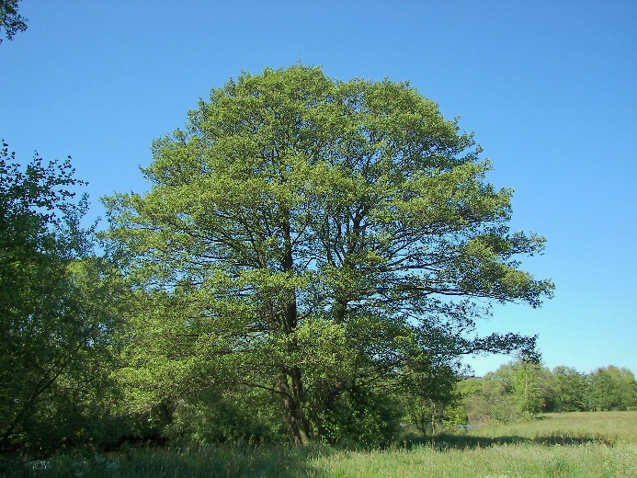

**Flowers and Fruit**

Alder is monoecious, it produces both male and female flowers on the same tree. The male catkins are pictured on the left, while the female fruits appear on the right.

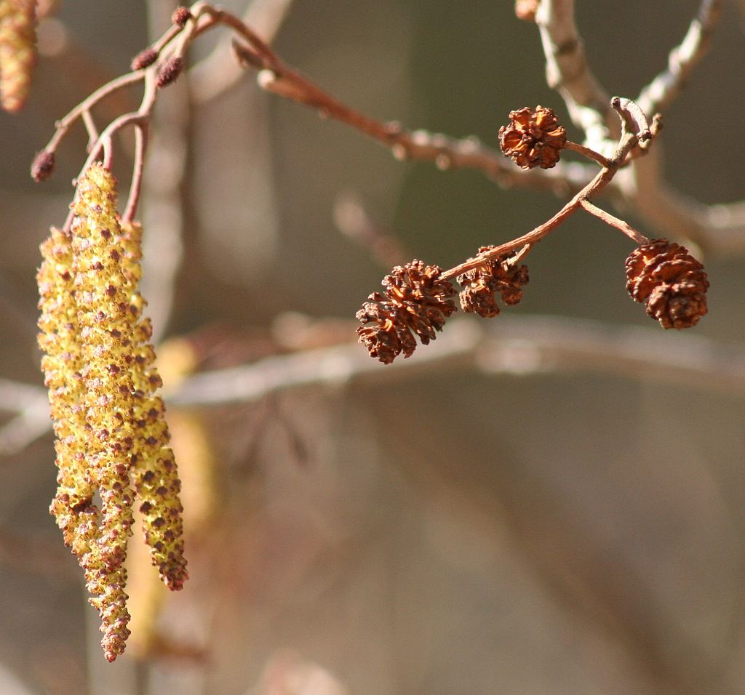

### **Bark**

As the bark ages, it becomes dark grey and fissured, younger bark has very noticeable white lenticels.

Young bark Mature bark

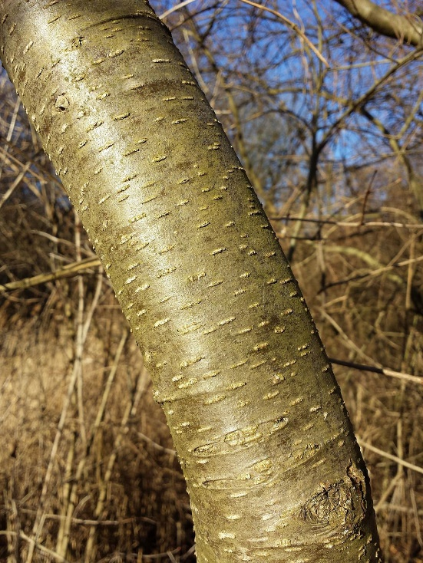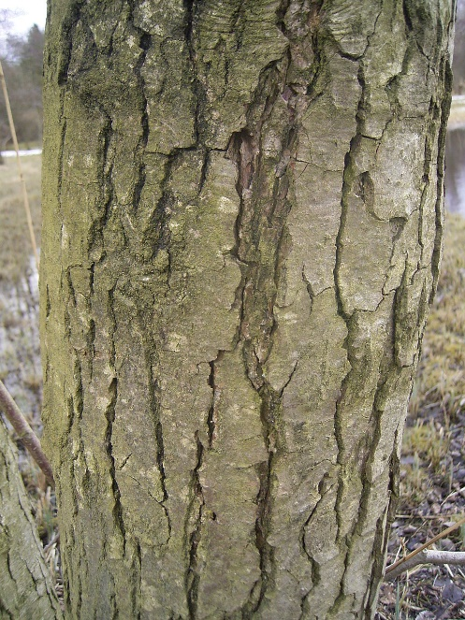

### **Leaves**

The leaves are rounded and some describe it as being pear-shaped. The margin is toothed, but there are fewer teeth towards the leaf stem. There are usually 6-8 pairs of veins, which are almost ‘sunken’ into the surrounding leaf tissue. The leaves tend to remain on the trees until quite late in the year

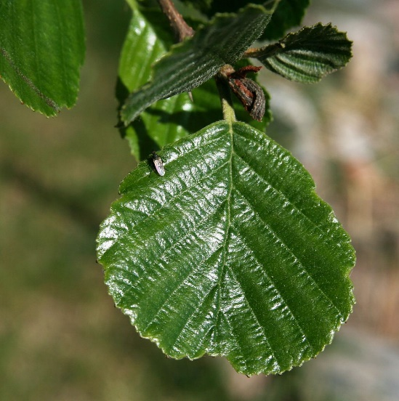

Alnus_glutinosa_Botanical Illustration

